OBJECT ORIENTED PROGRAMMING IN JAVA

LAB RECORD
Name: Tinaye Mazarire
Student Number: H250557X
Program: Software Engineering
Course: ISE 2102 – Object-Oriented Programming

Table of Contents

Lab 1: Classes and Objects ............................
Lab 2: Constructors, this Keyword and static Members .........
Lab 3: Encapsulation ..................................
Lab 4: Inheritance ....................................
Lab 5: Polymorphism ...................................
Lab 6: Abstraction ....................................
Lab 7: Exception Handling .............................
Lab 8: Generics and Collections ......................
Lab 9: Nested Types, Enums, Records ..................
Lab 10: File I/O, Lambdas and Streams ................
Lab 11: Mini-Project – Library Management System ....

LAB 1: Classes and Objects
Objectives
Define a class with fields (state) and methods (behaviour)
Create objects with new and access members with the dot operator
Understand that object variables hold references, not the objects themselves
Recognise null and avoid NullPointerException
Address.java
package lab1;
public class Address {
String city;
String street;
public Address(String city, String street) {
this.city = city;
this.street = street;
}
}
Car.java
package lab1;
public class Car {
// EXPLAIN: fields (state) for the car
String brand;
int year;
double mileage;
// EXPLAIN: method to display the car's details
void display() {
System.out.println("Brand: " + brand + ", Year: " + year + ", Mileage: " + mileage);
}
// EXPLAIN: Exercise 2 - returns true if the car is more than 25 years old
boolean isAntique() {
// Assuming the current year is 2026 based on your manual's date
int currentYear = 2026;
return (currentYear - year) > 25;
}
public static void main(String[] args) {
// Create three cars and print them
Car car1 = new Car();
car1.brand = "Toyota";
car1.year = 2010;
car1.mileage = 150000;
Car car2 = new Car();
car2.brand = "Ford";
car2.year = 1995; // This is more than 25 years old
car2.mileage = 250000;
Car car3 = new Car();
car3.brand = "Honda";
car3.year = 2022;
car3.mileage = 15000;
// Print them
car1.display();
System.out.println("Is Antique? " + car1.isAntique());
car2.display();
System.out.println("Is Antique? " + car2.isAntique());
car3.display();
System.out.println("Is Antique? " + car3.isAntique());
}
}
Output
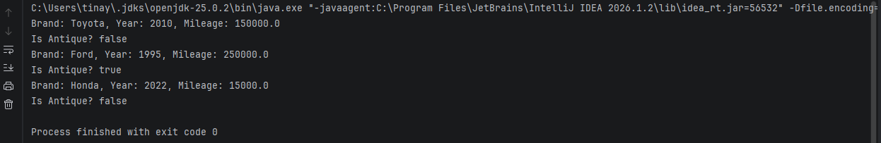
Person.java
package lab1;
public class Person {
String name;
Address address; // EXPLAIN: A field that is a reference to another object
public static void main(String[] args) {
// Scenario 1: Person has a valid address
Address addr = new Address("Harare", "Main Street");
Person p1 = new Person();
p1.name = "Tinashe";
p1.address = addr;
// EXPLAIN: Chained dot operator to access the city inside the address object
System.out.println("Person 1 City: " + p1.address.city);
// Scenario 2: Person has a null address
Person p2 = new Person();
p2.name = "Rudo";
p2.address = null; // The address is explicitly set to null
// EXPLAIN: We must check for null to avoid a NullPointerException
if (p2.address == null) {
System.out.println("Person 2 has no address (it is null).");
} else {
System.out.println("Person 2 City: " + p2.address.city);
}
}
}
Output
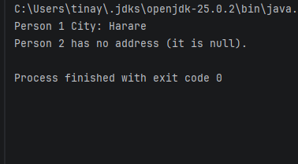

Rectangle.java
package lab1;
public class Rectangle {
double width;
double height;
// Method to calculate area
double area() {
return width * height;
}
// Method to calculate perimeter
double perimeter() {
return 2 * (width + height);
}
public static void main(String[] args) {
// Create an array of 5 rectangles
Rectangle[] rectangles = new Rectangle[5];
// Initialize the rectangles with different sizes
for (int i = 0; i < rectangles.length; i++) {
rectangles[i] = new Rectangle();
rectangles[i].width = (i + 1) * 2.0; // Widths: 2.0, 4.0, 6.0, 8.0, 10.0
rectangles[i].height = (i + 1) * 3.0; // Heights: 3.0, 6.0, 9.0, 12.0, 15.0
}
// Find the one with the largest area
Rectangle largest = rectangles[0];
for (int i = 1; i < rectangles.length; i++) {
if (rectangles[i].area() > largest.area()) {
largest = rectangles[i];
}
}
// Print the largest rectangle's details
System.out.println("The rectangle with the largest area is:");
System.out.println("Width: " + largest.width);
System.out.println("Height: " + largest.height);
System.out.println("Area: " + largest.area())
}
}
Output
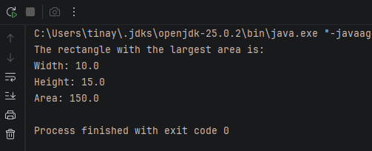
ReferencePrediction.java
package lab1;
public class ReferencePrediction {
public static void main(String[] args) {
// Create the first Rectangle
Rectangle r1 = new Rectangle();
r1.width = 5.0;
r1.height = 10.0;
// EXPLAIN: r2 is assigned the SAME memory address as r1.
// They are now aliases for the exact same object.
Rectangle r2 = r1;
// EXPLAIN: Changing r2 changes the single object that both r1 and r2 point to.
r2.width = 20.0;
// EXPLAIN: Because r1 and r2 point to the same object, r1.width is also changed.
System.out.println("r1.width: " + r1.width);
}
}

Output
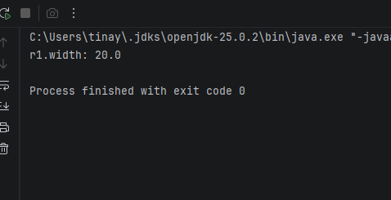
Conclusion
I learned how to define classes with fields and methods, create objects with new, and understand the object variables hold references, not the objects themselves
LAB 2: Constructors, this Keyword and static Members
Objectives
Initialise objects safely using constructors
Overload constructors and chain them with this(…)
Use this to distinguish fields from parameters
Explain the difference between instance members and static members
Use static and instance initialiser blocks
BlockOrder.java
package lab2;
public class BlockOrder {
// EXPLAIN: Static initializer blocks run ONCE when the class is first loaded.
// They run in the order they are written, top to bottom.
static {
System.out.println("Static block 1");
}
static {
System.out.println("Static block 2");
}
// EXPLAIN: Instance initializer blocks run EVERY time an object is created.
// They run in the order written, BEFORE the constructor body.
{
System.out.println("Instance block 1");
}
{
System.out.println("Instance block 2");
}
// Constructor
public BlockOrder() {
System.out.println("Constructor");
}
public static void main(String[] args) {
System.out.println("--- Creating first object ---");
new BlockOrder();
System.out.println("\n--- Creating second object ---");
new BlockOrder();
}
}

Output
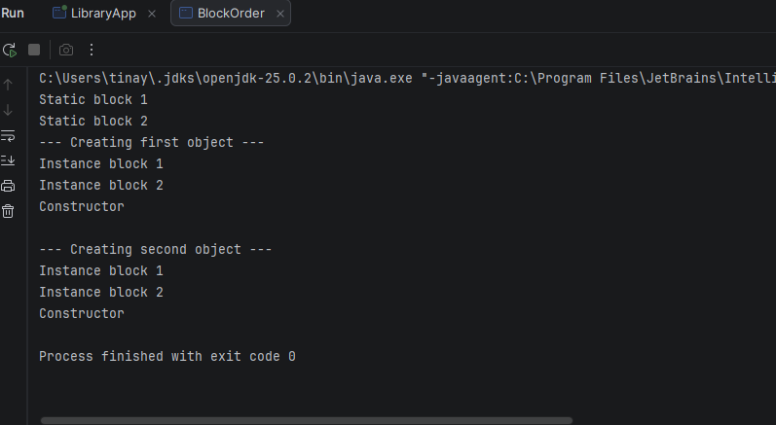
Circle.java
package lab2;
public class Circle {
private double radius;
// EXPLAIN: Static field -> ONE copy shared by all Circle objects
private static int count = 0;
// Constructor 1: Takes radius
public Circle(double radius) {
this.radius = radius;
count++; // Increment shared counter
}
// Constructor 2: No-argument constructor defaults radius to 1.0
public Circle() {
// EXPLAIN: Constructor chaining with this(...) must be the first statement
this(1.0);
}
// EXPLAIN: Static method -> belongs to the class, not the object. No 'this'.
public static int getCount() {
return count;
}
public void display() {
System.out.println("Circle radius: " + radius);
}
public static void main(String[] args) {
Circle c1 = new Circle(5.0);
Circle c2 = new Circle(); // Uses default 1.0
Circle c3 = new Circle(2.5);
c1.display();
c2.display();
c3.display();
// EXPLAIN: Accessing the static counter via the class name
System.out.println("Total circles created: " + Circle.getCount());
}
}

Output
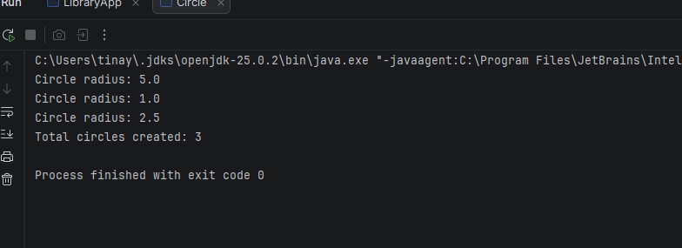

Employee.java
package lab2;
public class Employee {
private final int employeeId;
private String name;
private double salary;
// EXPLAIN: Static counter to track the next available ID
private static int nextId = 100;
// Constructor 1: Full initialization
public Employee(String name, double salary) {
this.name = name;
this.salary = salary;
// EXPLAIN: Auto-incrementing ID. Assigned exactly once.
this.employeeId = nextId++;
}
// Constructor 2: Constructor chaining (Defaults salary to 0.0)
public Employee(String name) {
this(name, 0.0);
}
// Constructor 3: No-argument constructor
public Employee() {
this("Unknown", 0.0);
}
// EXPLAIN: Copy constructor creates an independent object with the same values
public Employee(Employee other) {
// Note: This new object gets a NEW unique employeeId because of the constructor chain
this(other.name, other.salary);
}
public void display() {
System.out.printf("ID: %d | Name: %s | Salary: $%.2f%n", employeeId, name, salary);
}
public static void main(String[] args) {
Employee e1 = new Employee("Tinaye", 50000);
Employee e2 = new Employee("Witney"); // Defaults salary
Employee e3 = new Employee(); // Defaults everything
// Create a copy of e1
Employee e4 = new Employee(e1);
e1.display();
e2.display();
e3.display();
e4.display(); // Should have same name/salary as e1, but a new ID
}
}
Output
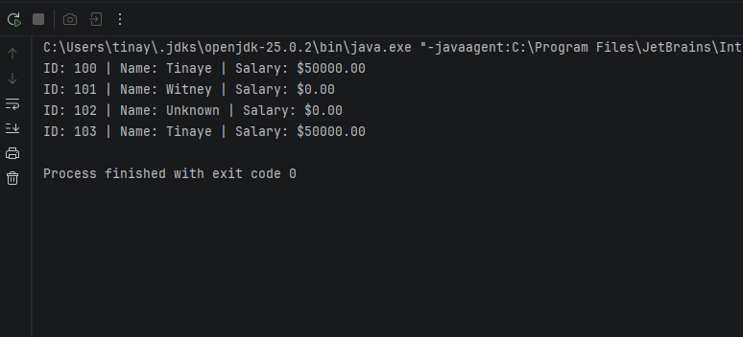

Temperature.java
package lab2;
public class Temperature {
private double celsius;
// EXPLAIN: Private constructor -> Cannot be called directly from outside.
// Forces the user to use the named factory methods instead.
private Temperature(double celsius) {
this.celsius = celsius;
}
// EXPLAIN: Static Factory Method for Celsius
public static Temperature fromCelsius(double c) {
return new Temperature(c);
}
// EXPLAIN: Static Factory Method for Fahrenheit
public static Temperature fromFahrenheit(double f) {
// Convert F to C using standard formula
double c = (f - 32) * 5.0 / 9.0;
return new Temperature(c);
}
public double getCelsius() {
return celsius;
}
public static void main(String[] args) {
// EXPLAIN: The code reads clearly. "Temperature from Celsius 25"
Temperature t1 = Temperature.fromCelsius(25.0);
// EXPLAIN: The code reads clearly. "Temperature from Fahrenheit 77"
Temperature t2 = Temperature.fromFahrenheit(77.0);
System.out.println("Temp 1 in Celsius: " + t1.getCelsius());
System.out.println("Temp 2 in Celsius: " + t2.getCelsius());
}
}

Output
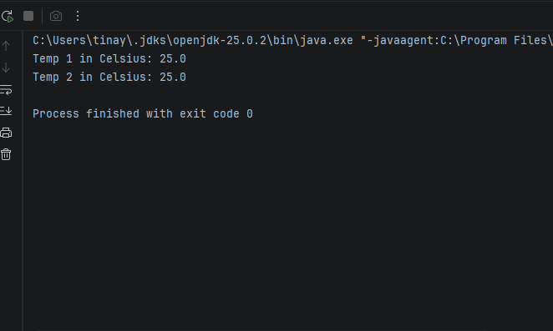
Conclusion
I learned how constructors initialize objects, how this(…) chains them, and the difference between static members(belonging to the class) and instance members (belonging to each object)
Lab 3: Encapsulation
Objectives
Hide internal data with private fields and expose it through controlled methods
Apply the four access levels correctly
Enforce validation rules(class invariants) inside setters and constructors
Design classes that cannot be put into an invalid state
BankAccount.java
package lab3;
import java.util.ArrayList;
import java.util.Collections;
import java.util.List;
public class BankAccount {
private final String accountNumber;
private String ownerName;
private double balance;
// EXPLAIN: Private list to hold transaction history
private final List<String> transactionHistory = new ArrayList<>();
public BankAccount(String accountNumber, String ownerName, double openingBalance) {
if (openingBalance < 0) {
throw new IllegalArgumentException("Opening balance cannot be negative");
}
this.accountNumber = accountNumber;
setOwnerName(ownerName);
this.balance = openingBalance;
transactionHistory.add("Account opened with balance: " + openingBalance);
}
public String getAccountNumber() { return accountNumber; }
public String getOwnerName() { return ownerName; }
public double getBalance() { return balance; }
public void setOwnerName(String ownerName) {
if (ownerName == null || ownerName.isBlank()) {
throw new IllegalArgumentException("Owner name required");
}
this.ownerName = ownerName.trim();
}
public void deposit(double amount) {
if (amount <= 0) {
throw new IllegalArgumentException("Deposit must be positive");
}
balance += amount;
transactionHistory.add("Deposited: " + amount);
}
public boolean withdraw(double amount) {
if (amount <= 0) {
throw new IllegalArgumentException("Withdrawal must be positive");
}
if (amount > balance) {
transactionHistory.add("Failed withdrawal attempt: " + amount);
return false;
}
balance -= amount;
transactionHistory.add("Withdrew: " + amount);
return true;
}
// EXPLAIN: Returning an unmodifiable copy prevents the caller from altering our internal list.
// This is the "defensive-copy trap" solution from Program 3.2.
public List<String> getTransactionHistory() {
return Collections.unmodifiableList(transactionHistory);
}
public static void main(String[] args) {
BankAccount acc = new BankAccount("ACC-001", "Tendai", 500.00);
acc.deposit(250.00);
acc.withdraw(100.00);
acc.withdraw(5000.00); // Should fail
System.out.println("Account: " + acc.getAccountNumber() + " | Balance: " + acc.getBalance());
System.out.println("Transaction History:");
for (String log : acc.getTransactionHistory()) {
System.out.println(" - " + log);
}
// Test the defensive copy
try {
acc.getTransactionHistory().clear();
} catch (UnsupportedOperationException e) {
System.out.println("\nSafe getter blocked modification of history.");
}
}
}

Output
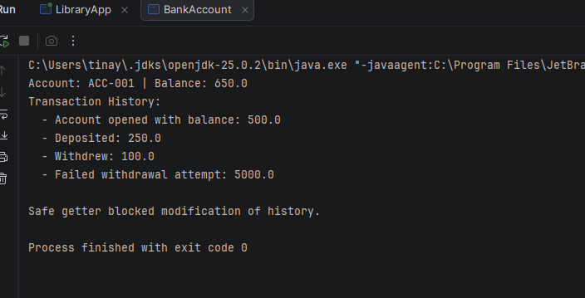
ImmutablePerson.java
package lab3;
// EXPLAIN: 'final' class -> Cannot be subclassed. This prevents a subclass from
// overriding methods and changing the immutable behavior.
public final class ImmutablePerson {
// EXPLAIN: 'final' fields -> The values are assigned once in the constructor
// and cannot be changed afterwards.
private final String name;
private final int age;
public ImmutablePerson(String name, int age) {
this.name = name;
this.age = age;
}
// EXPLAIN: Only getters, NO setters. Once created, the object's state is locked.
public String getName() { return name; }
public int getAge() { return age; }
public static void main(String[] args) {
ImmutablePerson p = new ImmutablePerson("Tinashe", 25);
System.out.println(p.getName() + " is " + p.getAge() + " years old.");
// p.name = "Rudo"; // COMPILE ERROR: Cannot assign a value to a final field
}
}

Output
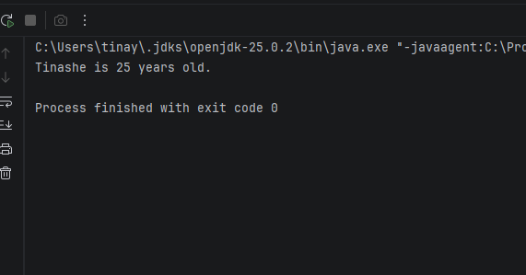

Student.java
package lab3;
public class Student {
private String name;
private double marks;
public Student(String name, double marks) {
setName(name);
setMarks(marks); // EXPLAIN: Reusing validation logic from the setter
}
public String getName() { return name; }
public void setName(String name) {
if (name == null || name.isBlank()) {
throw new IllegalArgumentException("Name cannot be empty");
}
this.name = name.trim();
}
public double getMarks() { return marks; }
public void setMarks(double marks) {
// EXPLAIN: Enforcing the class invariant (0 to 100) in the setter
if (marks < 0 || marks > 100) {
throw new IllegalArgumentException("Marks must be between 0 and 100");
}
this.marks = marks;
}
// EXPLAIN: getGrade() calculates the grade on the fly. It is NOT stored in a field.
public char getGrade() {
if (marks >= 80) return 'A';
if (marks >= 70) return 'B';
if (marks >= 60) return 'C';
if (marks >= 50) return 'D';
return 'F';
}
public static void main(String[] args) {
Student s1 = new Student("Tinashe", 85.5);
System.out.println(s1.getName() + " scored " + s1.getMarks() + " -> Grade: " + s1.getGrade());
// Test validation
try {
Student s2 = new Student("Rudo", 105);
} catch (IllegalArgumentException e) {
System.out.println("Rejected: " + e.getMessage());
}
}
}
Output
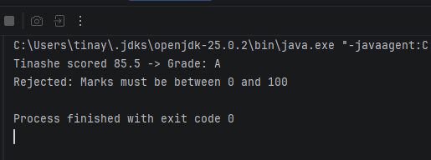

Temperature.java
package lab3;
public final class Temperature {
// EXPLAIN: Internal storage is always in Kelvin. This is our "canonical" unit.
private final double kelvin;
public Temperature(double kelvin) {
// EXPLAIN: Absolute zero is 0 Kelvin. Rejecting values below this prevents an invalid state.
if (kelvin < 0) {
throw new IllegalArgumentException("Temperature cannot be below absolute zero (0 K)");
}
this.kelvin = kelvin;
}
// Static factory methods for convenience (from Lab 2)
public static Temperature fromCelsius(double celsius) {
return new Temperature(celsius + 273.15);
}
public static Temperature fromFahrenheit(double fahrenheit) {
return new Temperature((fahrenheit - 32) * 5.0 / 9.0 + 273.15);
}
// EXPLAIN: The getter converts from the internal Kelvin unit to the requested unit on the fly.
public double getCelsius() {
return kelvin - 273.15;
}
public double getFahrenheit() {
return (kelvin - 273.15) * 9.0 / 5.0 + 32;
}
public double getKelvin() {
return kelvin;
}
public static void main(String[] args) {
Temperature t1 = Temperature.fromCelsius(25.0);
System.out.printf("Celsius: %.2f%n", t1.getCelsius());
System.out.printf("Fahrenheit: %.2f%n", t1.getFahrenheit());
System.out.printf("Kelvin: %.2f%n", t1.getKelvin());
// Test rejection of absolute zero
try {
Temperature t2 = Temperature.fromCelsius(-300.0);
} catch (IllegalArgumentException e) {
System.out.println("\nRejected: " + e.getMessage());
}
}
}

Output
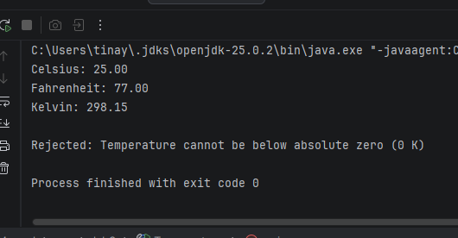
Conclusion
By keeping fields private and controlling access through getters and setters, I learned how to validate input and prevent objects from reaching invalid states
Lab 4: Inheritance
Objectives
Create subclasses with extends and reuse superclass code
Call superclass constructors and methods with supper
Use protected , final and the @Override annotation correctly
Explain the constructor call order and the role of java.lang.Object
Decide between inheritance (“is-a”) and composition (“has-a”)
AnimalDemo.java
Animal.java
Dog.java
package lab4;
// ============================================================
// Lab 4 - Exercise 4: Constructor Compilation Error
// ============================================================
// This program demonstrates why a subclass fails to compile
// when the superclass has no no-argument constructor.
//
// WHY THIS FAILS:
// When a subclass is created, Java automatically inserts
// a call to super() (the no-argument constructor of the parent)
// as the first statement of the subclass's constructor.
//
// But Animal only has Animal(String name) — there is NO
// no-argument constructor.
//
// Therefore, the compiler cannot insert super(), and the
// program fails to compile with:
// "constructor Animal in class Animal cannot be applied
// to given types; required: String; found: no arguments"
//
// HOW TO FIX:
// Add an explicit call: super(name);
// ============================================================
class Animal {
private String name;
// Only constructor: requires a String argument
public Animal(String name) {
this.name = name;
}
}
// This class WILL NOT COMPILE because the compiler tries to
// insert an implicit super() call, but Animal has no no-arg
// constructor.
//
// class Dog extends Animal {
// // No constructor here — compiler tries to insert super()
// }
// The corrected version — explicitly calls super(name)
class Dog extends Animal {
public Dog(String name) {
super(name); // Explicit call to the parent constructor
}
}
public class AnimalDemo {
public static void main(String[] args) {
Dog d = new Dog("Rex");
System.out.println("Dog created successfully with explicit super(name).");
}
}
Output
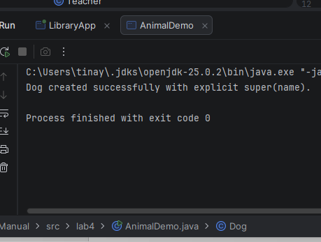
Person.java
ackage lab4;
public class Person {
// EXPLAIN: protected -> visible to subclasses (Student, Teacher)
protected String name;
protected int age;
public Person(String name, int age) {
this.name = name;
this.age = age;
}
public void display() {
System.out.println("Name: " + name + ", Age: " + age);
}
}
Stack.java
package lab4;
import java.util.ArrayList;
import java.util.List;
public class Stack<T> {
// EXPLAIN: Composition ("HAS-A"). The Stack class OWNS an ArrayList.
// This is better than "extends ArrayList" because a Stack is NOT an ArrayList
// (it shouldn't inherit methods like get(index) or add(index, element)).
private final List<T> elements = new ArrayList<>();
// EXPLAIN: We only expose the methods that are valid for a Stack.
public void push(T item) {
elements.add(item); // Add to the end
}
public T pop() {
if (isEmpty()) {
throw new IllegalStateException("Stack is empty");
}
// Remove and return the last item added
return elements.remove(elements.size() - 1);
}
public T peek() {
if (isEmpty()) {
throw new IllegalStateException("Stack is empty");
}
return elements.get(elements.size() - 1);
}
public boolean isEmpty() {
return elements.isEmpty();
}
public int size() {
return elements.size();
}
public static void main(String[] args) {
Stack<String> stack = new Stack<>();
stack.push("First");
stack.push("Second");
stack.push("Third");
System.out.println("Top of stack (peek): " + stack.peek()); // Third
System.out.println("Popped: " + stack.pop()); // Third
System.out.println("Popped: " + stack.pop()); // Second
System.out.println("Stack size now: " + stack.size()); // 1
// EXPLAIN: We CANNOT do this because Stack does not extend ArrayList.
// stack.get(0); // COMPILE ERROR: Method not available
}
}
Output
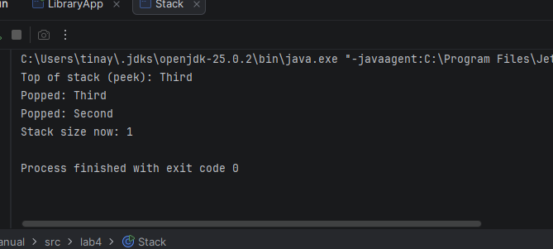
Student.java
package lab4;
public class Student extends Person { // EXPLAIN: Student IS-A Person
private String course;
public Student(String name, int age, String course) {
// EXPLAIN: super(...) must be the FIRST statement. Runs the parent constructor.
super(name, age);
this.course = course;
}
// EXPLAIN: Overriding the parent's display() to add Student-specific information
@Override
public void display() {
super.display(); // Reuse the parent's logic
System.out.println("Course: " + course);
}
public static void main(String[] args) {
Student s = new Student("Tinashe", 20, "Computer Science");
Teacher t = new Teacher("Mr. Smith", 45, "Mathematics");
System.out.println("--- Student Details ---");
s.display();
System.out.println("\n--- Teacher Details ---");
t.display(); // Inherited method works for Teacher too!
}
}
Output
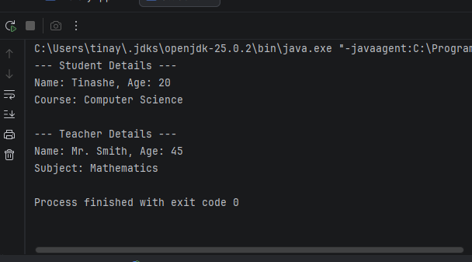

Teacher.java
package lab4;
public class Teacher extends Person { // EXPLAIN: Teacher IS-A Person
private String subject;
public Teacher(String name, int age, String subject) {
super(name, age);
this.subject = subject;
}
// EXPLAIN: Overriding to add the subject taught
@Override
public void display() {
super.display();
System.out.println("Subject: " + subject);
}
}
VehicleDemo.java
Car.java
Vehicle.java
ElectriCar.java
package lab4;
class Vehicle {
public Vehicle() {
System.out.println("Vehicle constructor");
}
}
class Car extends Vehicle {
public Car() {
// EXPLAIN: Implicit super() is called here automatically, running Vehicle's constructor first.
System.out.println("Car constructor");
}
}
class ElectricCar extends Car {
public ElectricCar() {
// EXPLAIN: Implicit super() runs Car's constructor, which in turn runs Vehicle's.
System.out.println("ElectricCar constructor");
}
public static void main(String[] args) {
System.out.println("--- Creating an ElectricCar ---");
new ElectricCar();
}
}
Output
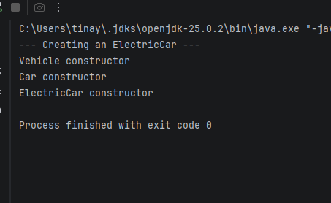
Conclusion
I learned how subclasses extend superclasses , how constructors run from parent to child and that composition is often safer than inheritance
Lab 5: Polymorphism
Objectives
Distinguish compile-time polymorphism(overloading) from run-time polymorphism(overriding)
Use a superclass reference to hold subclass objects(upcasting) and explain dynamic method dispatch
Downcast safely with instanceof and pattern matching
Write code that works with new subclasses without modification(theopen/closed idea)
AnimalDemo.java
Animal.java
Cat.java
Cow.java
Duck.java
package lab5;
// EXPLAIN: The superclass defines the common behavior (sound)
class Animal {
public void sound() {
System.out.println("Some generic animal sound");
}
}
class Cat extends Animal {
@Override
public void sound() {
System.out.println("Meow");
}
}
class Cow extends Animal {
@Override
public void sound() {
System.out.println("Moo");
}
}
class Duck extends Animal {
@Override
public void sound() {
System.out.println("Quack");
}
}
public class AnimalDemo {
public static void main(String[] args) {
// EXPLAIN: Upcasting -> An Animal array holds different subclass objects.
Animal[] animals = { new Cat(), new Cow(), new Duck() };
// EXPLAIN: Run-time polymorphism. The JVM calls the sound() method of the
// ACTUAL object (Cat, Cow, or Duck) at runtime, not the declared type (Animal).
for (Animal a : animals) {
a.sound();
}
}
}

Output
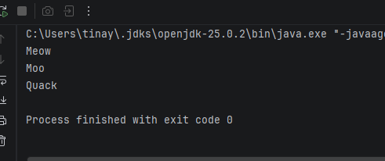
FieldVsMethod.java
Child.java
Parent.java
package lab5;
class Parent {
// EXPLAIN: Fields are NOT polymorphic. They are resolved at compile time based on the reference type.
public String name = "Parent Field";
// EXPLAIN: Methods ARE polymorphic. They are resolved at runtime based on the object type.
public String getName() {
return "Parent Method";
}
}
class Child extends Parent {
// EXPLAIN: This HIDES the parent's field, it does not override it.
public String name = "Child Field";
@Override
public String getName() {
return "Child Method";
}
}
public class FieldVsMethod {
public static void main(String[] args) {
// Upcast: A Parent reference pointing to a Child object
Parent p = new Child();
// EXPLAIN: Field access follows the DECLARED type (Parent).
// Therefore, it prints "Parent Field".
System.out.println("Field access: " + p.name);
// EXPLAIN: Method access follows the ACTUAL object type (Child) due to dynamic dispatch.
// Therefore, it prints "Child Method".
System.out.println("Method access: " + p.getName());
}
}
Output
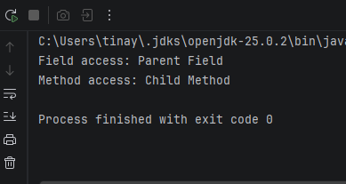
OverloadDemo.java
package lab5;
public class OverloadDemo {
// EXPLAIN: Compile-time polymorphism (Method Overloading). Same name, different parameters.
public void print(int i) {
System.out.println("Printing int: " + i);
}
public void print(double d) {
System.out.println("Printing double: " + d);
}
public void print(String s) {
System.out.println("Printing String: " + s);
}
public void print(int[] arr) {
System.out.print("Printing int array: [");
for (int i = 0; i < arr.length; i++) {
System.out.print(arr[i]);
if (i < arr.length - 1) System.out.print(", ");
}
System.out.println("]");
}
public static void main(String[] args) {
OverloadDemo demo = new OverloadDemo();
// The compiler decides which method to call based on the argument type
demo.print(10);
demo.print(3.14);
demo.print("Hello Java");
demo.print(new int[]{1, 2, 3, 4, 5});
}
}

Output
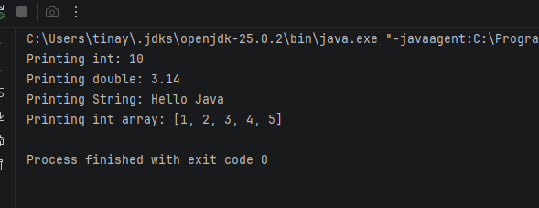
PaymentDemo.java
CardPayment.java
MobileMoneyPayment.java
Payment.java
PaymentProcessor.java
package lab5;
// Interface (Contract for all payments)
interface Payment {
void process();
}
class CardPayment implements Payment {
@Override
public void process() {
System.out.println("Processing card payment...");
}
}
class MobileMoneyPayment implements Payment {
@Override
public void process() {
System.out.println("Processing mobile money payment...");
}
}
class PaymentProcessor {
// DESIGN 1: The "Bad" way using instanceof pattern matching.
// EXPLAIN: This violates the Open/Closed Principle. If we add a new payment type,
// we MUST come back and modify this method (add another else-if).
public void pay(Payment p) {
if (p instanceof CardPayment card) {
card.process();
} else if (p instanceof MobileMoneyPayment mobile) {
mobile.process();
} else {
System.out.println("Unknown payment type");
}
}
// DESIGN 2: The "Polymorphic" way.
// EXPLAIN: This is better. The method doesn't care what type of payment it is.
// If we add a new payment type later, this method DOES NOT need to change.
public void polymorphicPay(Payment p) {
p.process();
}
}
public class PaymentDemo {
public static void main(String[] args) {
PaymentProcessor processor = new PaymentProcessor();
Payment card = new CardPayment();
Payment mobile = new MobileMoneyPayment();
System.out.println("--- Design 1 (instanceof) ---");
processor.pay(card);
processor.pay(mobile);
System.out.println("\n--- Design 2 (Polymorphic) ---");
processor.polymorphicPay(card);
processor.polymorphicPay(mobile);
}
}

Output
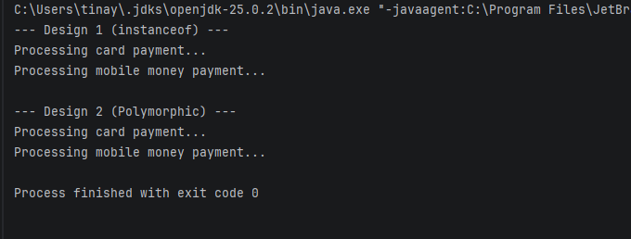
PayrollDemo.java
Developer.java
Employee.java
Intern.java
Manager.java

package lab5;
// Base Employee class (from Lab 4)
class Employee {
protected String name;
protected double baseSalary;
public Employee(String name, double baseSalary) {
this.name = name;
this.baseSalary = baseSalary;
}
public double calculatePay() {
return baseSalary;
}
public String getName() { return name; }
}
// Manager subclass
class Manager extends Employee {
private double bonus;
public Manager(String name, double baseSalary, double bonus) {
super(name, baseSalary);
this.bonus = bonus;
}
@Override
public double calculatePay() {
return baseSalary + bonus;
}
}
// Developer subclass
class Developer extends Employee {
private int overtimeHours;
private static final double OVERTIME_RATE = 25.0;
public Developer(String name, double baseSalary, int overtimeHours) {
super(name, baseSalary);
this.overtimeHours = overtimeHours;
}
@Override
public double calculatePay() {
return baseSalary + (overtimeHours * OVERTIME_RATE);
}
}
// NEW: Intern subclass
class Intern extends Employee {
public Intern(String name, double baseSalary) {
super(name, baseSalary);
}
// EXPLAIN: No need to override calculatePay() because interns just get baseSalary.
}
public class PayrollDemo {
public static void main(String[] args) {
// EXPLAIN: Polymorphic array holding different types of employees
Employee[] staff = {
new Employee("Kudzai", 2000),
new Manager("Nyasha", 3500, 800),
new Developer("Tatenda", 3000, 10),
new Intern("Rudo", 500) // New subclass added without breaking the loop
};
double totalPayroll = 0;
System.out.println("--- Processing Payroll ---");
// EXPLAIN: The payroll loop does NOT need to change to support the new Intern class.
// This is the "Open/Closed Principle" in action.
for (Employee e : staff) {
double pay = e.calculatePay();
System.out.printf("%-10s earns %.2f%n", e.getName(), pay);
totalPayroll += pay;
}
System.out.printf("%nTotal Payroll: %.2f%n", totalPayroll);
}
}
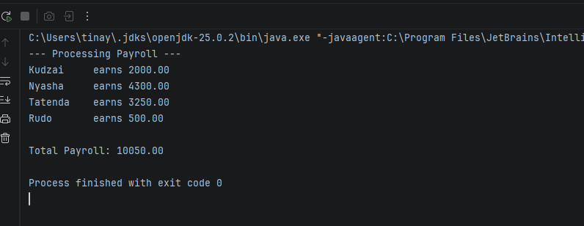
Conclusion
I learned the difference between overloading(compile-time) and overriding (runtime) and how dynamic method dispatch picks the correct method based on the objects actual type

Lab 6: Abstraction
Objectives
Define abstract classes and abstract methods and explain why they cannot be instantiated
Define and implement interfaces, including default static methods
Choose correctly between an abstract class and an interface
Program to an interface, not to an implementation
AccountDemo.java
Account.java
CurrentAccount.java
SavingsAccount.java
package lab6;
abstract class Account {
protected double balance;
protected String accountNumber;
public Account(String accountNumber, double initialBalance) {
this.accountNumber = accountNumber;
this.balance = initialBalance;
}
// EXPLAIN: Concrete method -> shared behavior for ALL accounts
public void deposit(double amount) {
if (amount > 0) {
balance += amount;
System.out.printf("Deposited %.2f. New balance: %.2f%n", amount, balance);
}
}
// EXPLAIN: Abstract method -> forces each subclass to define its own fee logic
public abstract void monthlyFee();
}
class SavingsAccount extends Account {
public SavingsAccount(String accountNumber, double initialBalance) {
super(accountNumber, initialBalance);
}
@Override
public void monthlyFee() {
// Savings accounts typically earn interest, so no monthly fee
System.out.println("Savings Account: No monthly fee. Balance: " + balance);
}
}
class CurrentAccount extends Account {
private final double fee = 15.0;
public CurrentAccount(String accountNumber, double initialBalance) {
super(accountNumber, initialBalance);
}
@Override
public void monthlyFee() {
balance -= fee;
System.out.printf("Current Account: Monthly fee of %.2f deducted. New balance: %.2f%n", fee, balance);
}
}
public class AccountDemo {
public static void main(String[] args) {
Account savings = new SavingsAccount("SAV-001", 1000);
Account current = new CurrentAccount("CUR-001", 500);
savings.deposit(500); // Shared concrete method
savings.monthlyFee(); // Savings-specific logic
System.out.println();
current.deposit(200); // Shared concrete method
current.monthlyFee(); // Current-specific logic
}
}

Output
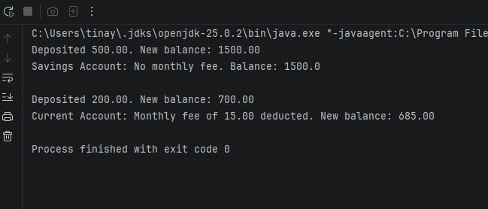
DiamondConflictDemo.java
InterfaceA
InterfaceB
Myclass
package lab6;
interface InterfaceA {
default void hello() {
System.out.println("Hello from Interface A");
}
}
interface InterfaceB {
default void hello() {
System.out.println("Hello from Interface B");
}
}
// EXPLAIN: When a class implements two interfaces that have the SAME default method,
// the compiler forces us to OVERRIDE the method to resolve the ambiguity.
// If we don't, it is a compile-time error.
class MyClass implements InterfaceA, InterfaceB {
// EXPLAIN: We must explicitly choose which one to call using InterfaceName.super.methodName()
@Override
public void hello() {
InterfaceA.super.hello(); // Calls InterfaceA's version
InterfaceB.super.hello(); // Calls InterfaceB's version
System.out.println("Hello from MyClass");
}
}
public class DiamondConflictDemo {
public static void main(String[] args) {
MyClass obj = new MyClass();
obj.hello();
}
}
Output
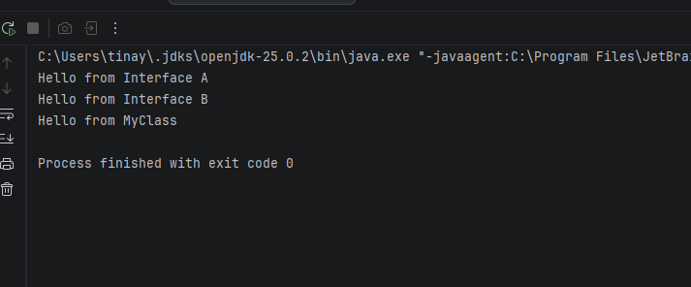
FlyableDemo.java
Aeroplane
Bird
Flyable
package lab6;
// EXPLAIN: Interface -> a pure contract. It defines WHAT can be done, not HOW.
interface Flyable {
void fly();
}
// EXPLAIN: Bird has no relationship with Aeroplane, but both can fly.
class Bird implements Flyable {
@Override
public void fly() {
System.out.println("Bird flaps its wings and flies.");
}
}
class Aeroplane implements Flyable {
@Override
public void fly() {
System.out.println("Aeroplane uses jet engines to fly.");
}
}
public class FlyableDemo {
public static void main(String[] args) {
// EXPLAIN: Program to an interface, not an implementation.
Flyable[] flyingObjects = { new Bird(), new Aeroplane() };
for (Flyable f : flyingObjects) {
f.fly(); // Dynamic dispatch determines which fly() to call
}
}
}
Output
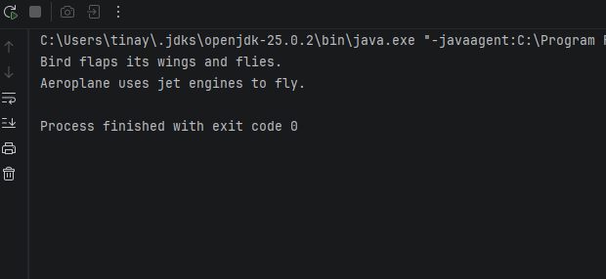
ShapeDemo.java
Circle
Rectangle
Shape
Square
package lab6;
// EXPLAIN: Abstract class -> cannot be instantiated. It defines a template for subclasses.
abstract class Shape {
// Abstract methods -> no body. Subclasses MUST provide the implementation.
abstract double area();
abstract double perimeter();
}
class Circle extends Shape {
private final double radius;
public Circle(double radius) { this.radius = radius; }
@Override
double area() { return Math.PI * radius * radius; }
@Override
double perimeter() { return 2 * Math.PI * radius; }
}
class Rectangle extends Shape {
protected double width, height;
public Rectangle(double width, double height) {
this.width = width;
this.height = height;
}
@Override
double area() { return width * height; }
@Override
double perimeter() { return 2 * (width + height); }
}
class Square extends Rectangle {
// EXPLAIN: A Square IS-A Rectangle. We just enforce equal width and height.
public Square(double side) {
super(side, side);
}
}
public class ShapeDemo {
public static void main(String[] args) {
// EXPLAIN: Polymorphic array holding abstract Shape references.
Shape[] shapes = { new Circle(5), new Rectangle(4, 6), new Square(4) };
for (Shape s : shapes) {
System.out.printf("%-10s Area: %.2f | Perimeter: %.2f%n",
s.getClass().getSimpleName(), s.area(), s.perimeter());
}
}
}
Output
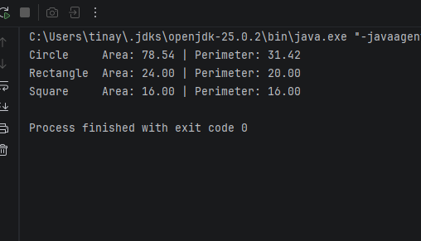

StudentSortDemo.java
Student
package lab6;
import java.util.ArrayList;
import java.util.Collections;
import java.util.Comparator;
import java.util.List;
class Student implements Comparable<Student> {
private String name;
private double marks;
public Student(String name, double marks) {
this.name = name;
this.marks = marks;
}
public String getName() { return name; }
public double getMarks() { return marks; }
// EXPLAIN: Natural ordering -> sorted alphabetically by name (A-Z)
@Override
public int compareTo(Student other) {
return this.name.compareTo(other.name);
}
@Override
public String toString() {
return name + " (" + marks + ")";
}
}
public class StudentSortDemo {
public static void main(String[] args) {
List<Student> students = new ArrayList<>();
students.add(new Student("Blessing", 95));
students.add(new Student("Anesu", 70));
students.add(new Student("Chenai", 82));
// Sort using Comparable (by name)
Collections.sort(students);
System.out.println("Sorted by name (Comparable):");
System.out.println(students);
// EXPLAIN: Comparator -> Custom sorting logic that lives OUTSIDE the class.
// Sort by marks descending (highest first)
Comparator<Student> byMarksDescending = (s1, s2) -> Double.compare(s2.getMarks(), s1.getMarks());
students.sort(byMarksDescending);
System.out.println("\nSorted by marks (Comparator, descending):");
System.out.println(students);
}
}
Output
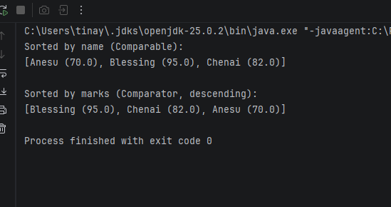
Conclusion
I learned that abstract classes provide shared state and partial code, while interfaces define pure contracts that unrelated classes can implement
Lab 7: Exception Handling
Objectives
Explain the exception hierarchy and the difference between checked and unchecked exceptions
Use try, catch, finally, throw and throws correctly
Create custom exceptions that carries useful information
Manages resources safely with try-with-resources
Write methods that fail predictably instead of leaving objects in a bad state

AgeValidator.java
package lab7;
public class AgeValidator {
// EXPLAIN: 'throws' warns the caller that they must handle this checked exception
public static void validateAge(int age) throws InvalidAgeException {
if (age < 0 || age > 120) {
// EXPLAIN: 'throw' creates and throws the exception object
throw new InvalidAgeException("Invalid age: " + age + ". Age must be between 0 and 120.");
}
System.out.println("Age " + age + " is valid.");
}
public static void main(String[] args) {
try {
validateAge(25); // Valid
validateAge(150); // Invalid -> throws exception
} catch (InvalidAgeException e) {
System.out.println("Caught: " + e.getMessage());
}
}
}

Output
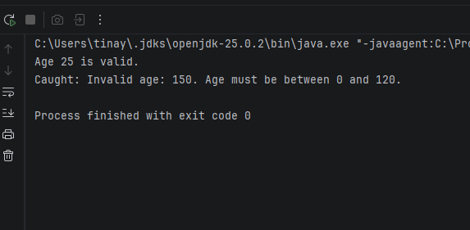
ArrayAccessDemo.java
package lab7;
public class ArrayAccessDemo {
// EXPLAIN: This method is risky. It tries to access an index that may not exist.
public static void accessElement(int[] arr, int index) {
try {
System.out.println("Value at index " + index + ": " + arr[index]);
} catch (ArrayIndexOutOfBoundsException e) {
// EXPLAIN: Catches the specific error where the index is outside 0 to length-1.
System.out.println("Error: Index " + index + " is out of bounds for array of length " + arr.length);
}
}
public static void main(String[] args) {
int[] numbers = {10, 20, 30};
// Valid access
accessElement(numbers, 1); // Prints 20
// Invalid access (Index 5 does not exist)
accessElement(numbers, 5); // Triggers the catch block
}
}
Output
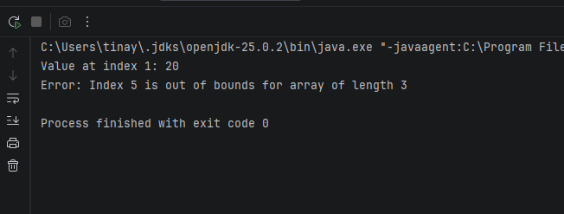
BankAccount.java
package lab7;
public class BankAccount {
private final String accountNumber;
private double balance;
public BankAccount(String accountNumber, double openingBalance) {
this.accountNumber = accountNumber;
this.balance = openingBalance;
}
public void deposit(double amount) {
if (amount <= 0) {
throw new IllegalArgumentException("Deposit must be positive");
}
balance += amount;
}
// EXPLAIN: Instead of returning false, this method now throws a custom exception.
public void withdraw(double amount) throws InsufficientFundsException {
if (amount <= 0) {
throw new IllegalArgumentException("Withdrawal must be positive");
}
if (amount > balance) {
// EXPLAIN: Creating and throwing the custom checked exception with useful info
throw new InsufficientFundsException(
"Cannot withdraw " + amount + "; balance is " + balance,
amount - balance
);
}
balance -= amount;
}
public double getBalance() { return balance; }
public static void main(String[] args) {
BankAccount acc = new BankAccount("ACC-001", 100.0);
try {
acc.withdraw(60.0);
System.out.println("Balance after withdrawal: " + acc.getBalance());
acc.withdraw(60.0); // This will fail
} catch (InsufficientFundsException e) {
System.out.println(e.getMessage());
System.out.println("Short by: " + e.getShortfall());
}
}
}

Output
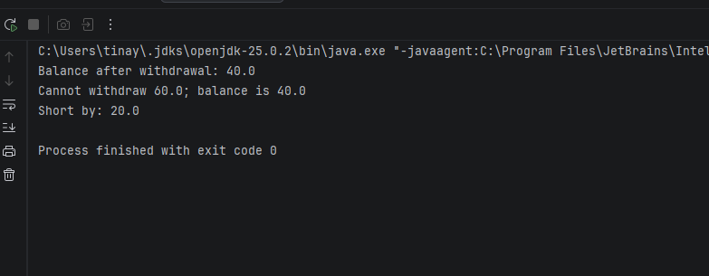
DivisionDemo.java
package lab7;
import java.util.InputMismatchException;
import java.util.Scanner;
public class DivisionDemo {
public static void main(String[] args) {
Scanner scanner = new Scanner(System.in);
try {
System.out.print("Enter the first integer: ");
int num1 = scanner.nextInt();
System.out.print("Enter the second integer: ");
int num2 = scanner.nextInt();
// EXPLAIN: This line can throw an ArithmeticException if num2 is 0.
int result = num1 / num2;
System.out.println("Result: " + num1 + " / " + num2 + " = " + result);
} catch (InputMismatchException e) {
// EXPLAIN: Catches non-numeric input (e.g. typing "abc" instead of a number)
System.out.println("Error: Please enter valid integers only.");
} catch (ArithmeticException e) {
// EXPLAIN: Catches division by zero
System.out.println("Error: Cannot divide by zero!");
} finally {
// EXPLAIN: The finally block always runs, even if an exception is caught.
scanner.close();
System.out.println("Program finished.");
}
}
}

Output
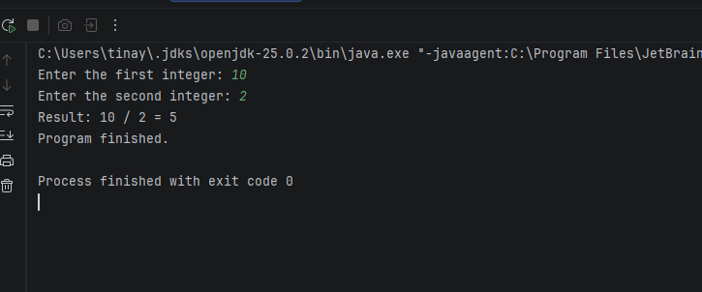
FinallyReturnDemo.java
package lab7;
public class FinallyReturnDemo {
public static int testMethod() {
try {
System.out.println("Inside try block. About to return 10.");
return 10; // EXPLAIN: The return statement is evaluated, but not executed yet.
} finally {
// EXPLAIN: The finally block ALWAYS runs before the method actually returns.
System.out.println("Inside finally block. This runs before the actual return.");
}
}
public static void main(String[] args) {
int result = testMethod();
System.out.println("Method returned: " + result);
}
}

Output
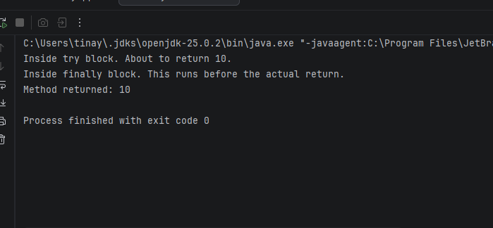
InsufficientFundsException.java
package lab7;
public class InsufficientFundsException extends Exception {
private final double shortfall;
public InsufficientFundsException(String message, double shortfall) {
super(message);
this.shortfall = shortfall;
}
public double getShortfall() {
return shortfall;
}
}
InvalidAgeException.java
package lab7;
// EXPLAIN: Extending Exception makes this a CHECKED exception.
// Callers MUST handle it or declare it with 'throws'.
public class InvalidAgeException extends Exception {
public InvalidAgeException(String message) {
super(message); // Pass the message to the parent Exception class
}
}

Conclusion
I learned the difference between checked and unchecked exceptions, how to create custom exceptions, and that finally always runs even after a return
Lab 8: Generics and collections
Objectives
Write generics classes and method, including bounded type parameters
Explain type erasure and why primitives need wrapper classes
Choose the write collection: List, Set, Queue
Sort and search with comparable, comparator and collections
Program to the interface (List<String> x = new ArrayList<>())
ArrayListDemo.java
package lab8;
import java.util.ArrayList;
import java.util.Collections;
import java.util.List;
public class ArrayListDemo {
public static void main(String[] args) {
// EXPLAIN: Programming to the interface (List) but using ArrayList implementation.
List<Integer> numbers = new ArrayList<>();
// Add 10 integers
for (int i = 1; i <= 10; i++) {
numbers.add(i * 5); // Adds 5, 10, 15, ... 50
}
// Calculate sum
int sum = 0;
for (int num : numbers) {
sum += num;
}
// Find maximum
int max = Collections.max(numbers);
// Print results
System.out.println("List: " + numbers);
System.out.println("Sum: " + sum);
System.out.println("Maximum: " + max);
// EXPLAIN: Reverse the list in-place
Collections.reverse(numbers);
System.out.println("Reversed List: " + numbers);
}
}

Output
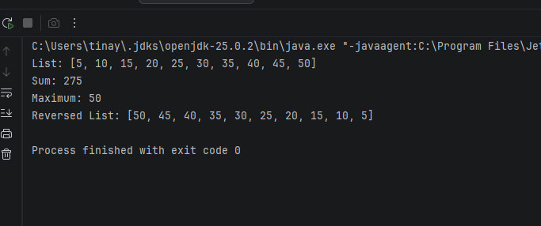
GenericSortDemo.java
package lab8;
public class GenericSortDemo {
// EXPLAIN: <T extends Comparable<T>> is a bounded type parameter.
// It guarantees that whatever type T is, it has a compareTo() method.
public static <T extends Comparable<T>> void bubbleSort(T[] arr) {
int n = arr.length;
for (int i = 0; i < n - 1; i++) {
for (int j = 0; j < n - i - 1; j++) {
// EXPLAIN: compareTo returns > 0 if arr[j] is greater than arr[j+1]
if (arr[j].compareTo(arr[j + 1]) > 0) {
// Swap elements
T temp = arr[j];
arr[j] = arr[j + 1];
arr[j + 1] = temp;
}
}
}
}
// Helper method to print arrays
public static <T> void printArray(T[] arr) {
for (T element : arr) {
System.out.print(element + " ");
}
System.out.println();
}
public static void main(String[] args) {
// Test with Integer array
Integer[] intArray = {64, 34, 25, 12, 22, 11, 90};
System.out.print("Original Integer array: ");
printArray(intArray);
bubbleSort(intArray);
System.out.print("Sorted Integer array: ");
printArray(intArray);
// Test with String array
String[] strArray = {"banana", "apple", "cherry", "date", "elderberry"};
System.out.print("\nOriginal String array: ");
printArray(strArray);
bubbleSort(strArray);
System.out.print("Sorted String array: ");
printArray(strArray);
}
}

Output
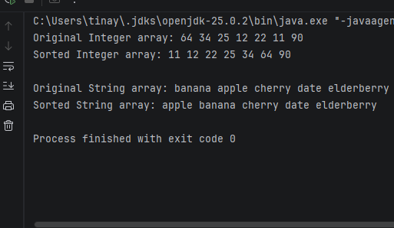
GenericStack.java
package lab8;
import java.util.ArrayList;
import java.util.List;
// EXPLAIN: <T> is a generic type parameter. It can be replaced by any reference type (String, Integer, etc.)
public class GenericStack<T> {
// EXPLAIN: Composition -> The Stack class HAS-A List internally.
private final List<T> elements = new ArrayList<>();
public void push(T item) {
elements.add(item);
}
public T pop() {
if (isEmpty()) {
throw new IllegalStateException("Stack is empty");
}
return elements.remove(elements.size() - 1);
}
public T peek() {
if (isEmpty()) {
throw new IllegalStateException("Stack is empty");
}
return elements.get(elements.size() - 1);
}
public boolean isEmpty() {
return elements.isEmpty();
}
public int size() {
return elements.size();
}
public static void main(String[] args) {
// EXPLAIN: Using the generic Stack with String
GenericStack<String> stringStack = new GenericStack<>();
stringStack.push("First");
stringStack.push("Second");
stringStack.push("Third");
System.out.println("Top of stack (peek): " + stringStack.peek());
System.out.println("Popped: " + stringStack.pop());
System.out.println("Popped: " + stringStack.pop());
System.out.println("Stack size now: " + stringStack.size());
}
}
Output
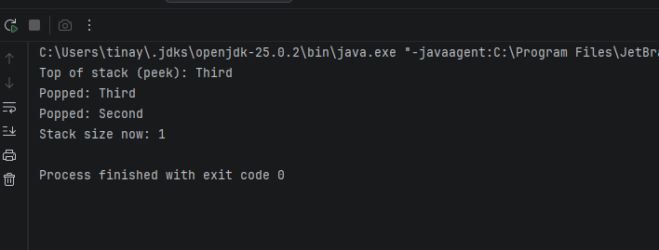

UniqueNamesDemo.java
package lab8;
import java.util.ArrayList;
import java.util.HashSet;
import java.util.List;
import java.util.Set;
public class UniqueNamesDemo {
public static void main(String[] args) {
List<String> names = new ArrayList<>();
names.add("Tinashe");
names.add("Rudo");
names.add("Tinashe"); // Duplicate
names.add("Farai");
names.add("Rudo"); // Duplicate
names.add("Nyasha");
System.out.println("Original list with duplicates: " + names);
// EXPLAIN: A Set does not allow duplicates.
// Passing the List into the Set constructor automatically removes duplicates.
Set<String> uniqueNames = new HashSet<>(names);
// EXPLAIN: Converting back to a List (optional, but often useful)
List<String> cleanedList = new ArrayList<>(uniqueNames);
System.out.println("List after removing duplicates: " + cleanedList);
}
}

Output
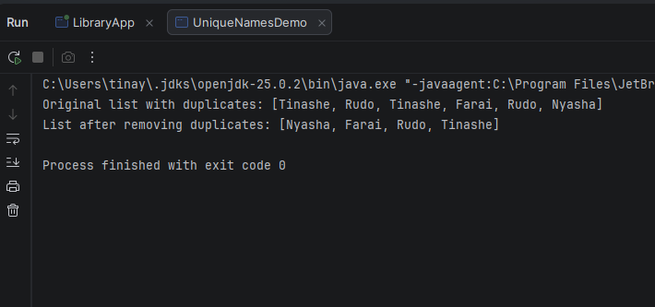

WordFrequency.java
package lab8;
import java.util.ArrayList;
import java.util.Comparator;
import java.util.HashMap;
import java.util.List;
import java.util.Map;
public class WordFrequency {
public static void main(String[] args) {
String paragraph = "the quick brown fox jumps over the lazy dog the fox is quick";
// EXPLAIN: Map -> Key = word, Value = frequency
Map<String, Integer> frequencyMap = new HashMap<>();
// Split the paragraph into individual words (lowercase to handle case variations)
String[] words = paragraph.toLowerCase().split("\\s+");
for (String word : words) {
// EXPLAIN: merge() is a clean way to increment or initialize the count
frequencyMap.merge(word, 1, Integer::sum);
}
System.out.println("Word Frequencies: " + frequencyMap);
// EXPLAIN: To sort by frequency, we convert the Map entries into a List.
List<Map.Entry<String, Integer>> entries = new ArrayList<>(frequencyMap.entrySet());
// Sort by value (frequency) in DESCENDING order
entries.sort(Map.Entry.<String, Integer>comparingByValue().reversed());
System.out.println("\nSorted by frequency (descending):");
for (Map.Entry<String, Integer> entry : entries) {
System.out.println(entry.getKey() + ": " + entry.getValue());
}
}
}

Output
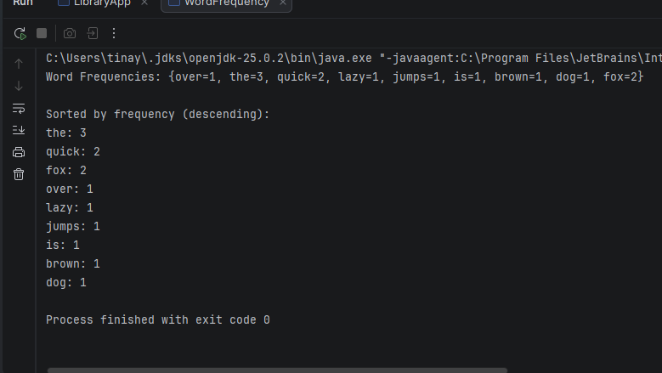
Conclusion
I learned how to use generics for type safety and how to choose the right collection(List,Set,Map) and stream operations for each task

Lab 9: Nested Types, Enums and Records
Objectives
Distinguish static nested, inner(member), local and anonymous classes
Model fixed sets of constants with enum, including fields, constructors and methods
Create immutable data carriers with record
Override equals, hashCode and tostring correctly and explain why they must be consistent
BookContractDemo.java
Book
package lab9;
import java.util.HashSet;
import java.util.Objects;
import java.util.Set;
class Book {
private final String isbn;
private final String title;
public Book(String isbn, String title) {
this.isbn = isbn;
this.title = title;
}
public String getIsbn() { return isbn; }
public String getTitle() { return title; }
// EXPLAIN: Equality is based ONLY on ISBN (the unique identifier)
@Override
public boolean equals(Object o) {
if (this == o) return true;
if (!(o instanceof Book book)) return false;
return Objects.equals(isbn, book.isbn);
}

Output
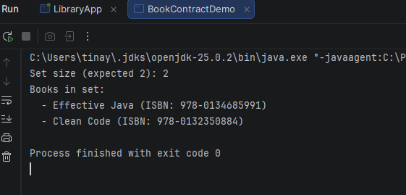
CoinChangeDemo.java
package lab9;
public enum CoinChangeDemo {
// EXPLAIN: Enum constants with associated values
PENNY(1), NICKEL(5), DIME(10), QUARTER(25);
private final int value;
// EXPLAIN: Constructor for the enum
CoinChangeDemo(int value) {
this.value = value;
}
public int getValue() {
return value;
}
// EXPLAIN: Static method that uses the enum constants to calculate change
public static void printFewestCoins(int amount) {
System.out.println("Fewest coins for " + amount + " cents:");
// Sort the values in descending order to use the largest coins first (Greedy algorithm)
CoinChangeDemo[] coins = { QUARTER, DIME, NICKEL, PENNY };
for (CoinChangeDemo coin : coins) {
if (amount >= coin.getValue()) {
int count = amount / coin.getValue();
amount = amount % coin.getValue();
System.out.println(" " + coin + " (" + coin.getValue() + "c) x " + count);
}
}
}
public static void main(String[] args) {
printFewestCoins(87);
System.out.println();
printFewestCoins(30);
}
Output
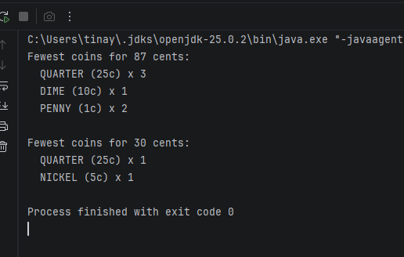
CustomLinkedList.java
package lab9;
import java.util.Iterator;
import java.util.NoSuchElementException;
public class CustomLinkedList<T> implements Iterable<T> {
// EXPLAIN: Static nested class -> Does not need an outer instance.
// Used as a helper "structure" for the data.
private static class Node<T> {
T data;
Node<T> next;
Node(T data) {
this.data = data;
this.next = null;
}
}
private Node<T> head;
private int size;
public void add(T data) {
Node<T> newNode = new Node<>(data);
if (head == null) {
head = newNode;
} else {
Node<T> current = head;
while (current.next != null) {
current = current.next;
}
current.next = newNode;
}
size++;
}
// EXPLAIN: Inner class -> Has a hidden reference to the outer CustomLinkedList instance.
// It can access the outer's private 'head' and 'size'.
public class LinkedListIterator implements Iterator<T> {
private Node<T> current = head;
@Override
public boolean hasNext() {
return current != null;
}
@Override
public T next() {
if (!hasNext()) throw new NoSuchElementException();
T data = current.data;
current = current.next;
return data;
}
}
// EXPLAIN: Iterable interface allows the for-each loop to work
@Override
public Iterator<T> iterator() {
return new LinkedListIterator();
}
public static void main(String[] args) {
CustomLinkedList<String> list = new CustomLinkedList<>();
list.add("First");
list.add("Second");
list.add("Third");
System.out.println("Iterating with for-each loop:");
for (String item : list) {
System.out.println(" - " + item);
}
}
}
Output
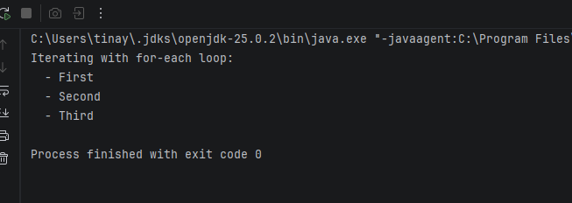
LevelDemo.java
package lab9;
public class LevelDemo {
// EXPLAIN: Enum -> A fixed set of constants. Type-safe and used in switch statements.
enum Level {
LOW, MEDIUM, HIGH
}
public static void main(String[] args) {
Level currentLevel = Level.MEDIUM;
// EXPLAIN: Switch expression (Java 14+) -> Compiler checks all cases are covered
String advice = switch (currentLevel) {
case LOW -> "You need to focus more and put in more effort.";
case MEDIUM -> "You are doing okay, but there is room for improvement.";
case HIGH -> "Excellent work! Keep it up!";
};
System.out.println("Level: " + currentLevel);
System.out.println("Advice: " + advice);
// Test the other levels
System.out.println();
for (Level l : Level.values()) {
System.out.println(l + " -> " + getAdvice(l));
}
}
// Traditional switch statement for comparison
public static String getAdvice(Level level) {
switch (level) {
case LOW: return "Work harder!";
case MEDIUM: return "Keep pushing!";
case HIGH: return "Great job!";
default: return "Unknown level";
}
}
}

Output
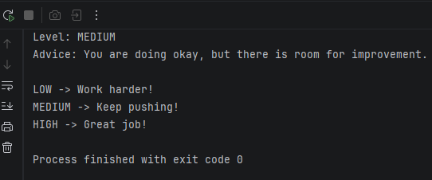
RecordDemo.java
Student
package lab9;
// EXPLAIN: A record is a compact, immutable data carrier. Java automatically generates:
// constructor, accessor methods (name(), age()), equals(), hashCode() and toString().
record Student(String name, int age) { }
public class RecordDemo {
public static void main(String[] args) {
Student s1 = new Student("Tinashe", 20);
Student s2 = new Student("Tinashe", 20);
Student s3 = new Student("Rudo", 22);
// EXPLAIN: toString() is auto-generated
System.out.println("Student 1: " + s1);
System.out.println("Student 2: " + s2);
System.out.println("Student 3: " + s3);
// EXPLAIN: equals() is auto-generated -> compares by value
System.out.println("\ns1.equals(s2): " + s1.equals(s2)); // true
System.out.println("s1.equals(s3): " + s1.equals(s3)); // false
// EXPLAIN: Accessor methods are auto-generated (note: no "get" prefix)
System.out.println("\nName: " + s1.name()); // read a component
System.out.println("Age: " + s1.age());
}
}
Output
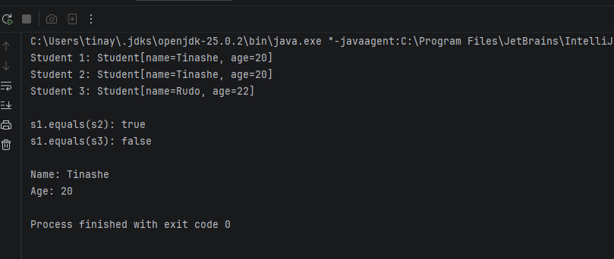
Conclusion
I learned about nested classes, enums and records and why equals and hashCode must be overridden together for hash-based collections to work
Lab 10: File I/O, Lambdas and Streams
Objectives
Read and write text files with java.nio.file and handle IOException
Persist and restore objects using CSV format
Write lambda expressions and method references and identify functional interfaces.
Process collections declaratively with the Stream API (filter, map, sorted, collect,reduce)
FileStatsDemo.java
package lab10;
import java.io.IOException;
import java.nio.file.Files;
import java.nio.file.Path;
import java.util.List;
public class FileStatsDemo {
public static void main(String[] args) {
Path filePath = Path.of("stats.txt");
// First, create a sample file so we have something to read
try {
Files.writeString(filePath, "Hello world\nThis is a test file\nJava is fun");
} catch (IOException e) {
System.out.println("Could not create file: " + e.getMessage());
return;
}
// Now read the file and calculate stats
try {
List<String> lines = Files.readAllLines(filePath);
int lineCount = lines.size();
int wordCount = 0;
int charCount = 0;
for (String line : lines) {
// Count characters (excluding newline characters)
charCount += line.length();
// EXPLAIN: split("\\s+") splits the line on whitespace (spaces, tabs, etc.)
if (!line.isBlank()) {
wordCount += line.trim().split("\\s+").length;
}
}
System.out.println("File: " + filePath);
System.out.println("Lines: " + lineCount);
System.out.println("Words: " + wordCount);
System.out.println("Characters: " + charCount);
} catch (IOException e) {
System.out.println("Error reading file: " + e.getMessage());
}
}
}

Output
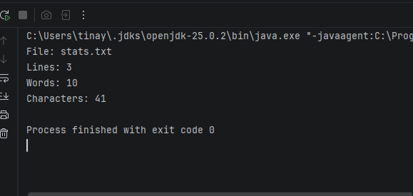

FileWriteReadDemo.java
package lab10;
import java.io.IOException;
import java.nio.file.Files;
import java.nio.file.Path;
import java.util.ArrayList;
import java.util.List;
import java.util.Scanner;
public class FileWriteReadDemo {
public static void main(String[] args) {
Path filePath = Path.of("user_lines.txt");
List<String> lines = new ArrayList<>();
Scanner scanner = new Scanner(System.in);
System.out.println("Please enter 5 lines of text:");
for (int i = 1; i <= 5; i++) {
System.out.print("Line " + i + ": ");
lines.add(scanner.nextLine());
}
scanner.close();
// EXPLAIN: Files.write() throws a checked IOException. We must handle it.
try {
Files.write(filePath, lines);
System.out.println("\nSuccessfully wrote 5 lines to " + filePath);
// EXPLAIN: Reading the file back into a List
List<String> readLines = Files.readAllLines(filePath);
System.out.println("\n--- Reading back from file ---");
for (String line : readLines) {
System.out.println(line);
}
} catch (IOException e) {
System.out.println("An I/O error occurred: " + e.getMessage());
}
}
}

Output
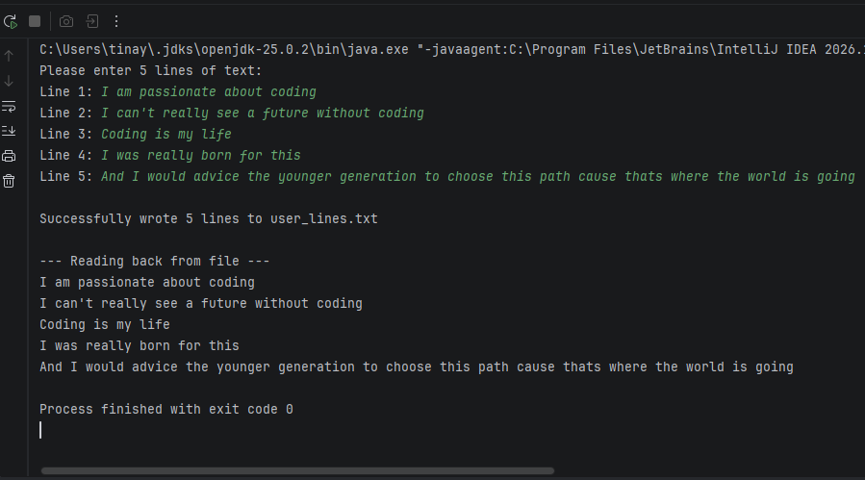
GradeReportDemo.java
Learner
package lab10;
import java.io.IOException;
import java.nio.file.Files;
import java.nio.file.Path;
import java.util.List;
import java.util.Map;
import java.util.stream.Collectors;
record Learner(String name, double gpa) { }
public class GradeReportDemo {
public static void main(String[] args) {
// 1. Create a sample learners.csv file
Path csvPath = Path.of("learners.csv");
try {
Files.write(csvPath, List.of(
"Tinashe,3.8",
"Rudo,2.9",
"Farai,3.5",
"Nyasha,1.8",
"Chipo,3.9",
"Tapiwa,2.5"
));
} catch (IOException e) {
System.out.println("Could not create CSV: " + e.getMessage());
return;
}
try {
// 2. Read lines and map to Learner objects
List<Learner> learners = Files.readAllLines(csvPath).stream()
.filter(line -> !line.isBlank())
.map(line -> {
String[] parts = line.split(",");
return new Learner(parts[0], Double.parseDouble(parts[1]));
})
.collect(Collectors.toList());
// EXPLAIN: Grouping by grade band.
// GPA >= 3.5 = A, >= 2.5 = B, else = C
Map<String, List<Learner>> grouped = learners.stream()
.collect(Collectors.groupingBy(l -> {
if (l.gpa() >= 3.5) return "A";
if (l.gpa() >= 2.5) return "B";
return "C";
}));
// 3. Write a report file per band
for (Map.Entry<String, List<Learner>> entry : grouped.entrySet()) {
String band = entry.getKey();
List<Learner> bandLearners = entry.getValue();
// Sort by name inside each band
bandLearners.sort((l1, l2) -> l1.name().compareTo(l2.name()));
Path reportPath = Path.of("report_" + band + ".txt");
List<String> reportLines = bandLearners.stream()
.map(l -> l.name() + " - GPA: " + l.gpa())
.collect(Collectors.toList());
Files.write(reportPath, reportLines);
System.out.println("Wrote report for Grade " + band + " -> " + reportPath);
}
} catch (IOException e) {
System.out.println("Error processing files: " + e.getMessage());
}
}
}
Output
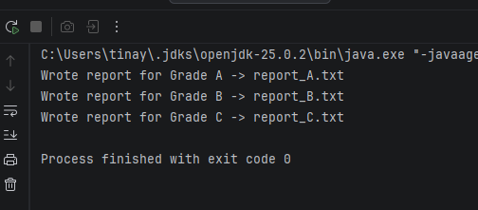
RemoveEvenDemo.java
package lab10;
import java.util.ArrayList;
import java.util.List;
import java.util.function.Predicate;
public class RemoveEvenDemo {
public static void main(String[] args) {
List<Integer> numbers = new ArrayList<>(List.of(1, 2, 3, 4, 5, 6, 7, 8, 9, 10));
System.out.println("Original list: " + numbers);
// EXPLAIN: Predicate<T> -> Functional interface that takes one argument and returns boolean.
// Here, it returns true if the number is even.
Predicate<Integer> isEven = n -> n % 2 == 0;
// EXPLAIN: removeIf() removes all elements that satisfy the Predicate.
numbers.removeIf(isEven);
System.out.println("List after removing evens: " + numbers);
}
}
Output
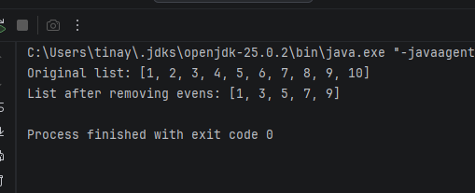
StudentStreamDemo.java
package lab10;
import java.util.Comparator;
import java.util.List;
import java.util.stream.Collectors;
record Student(String name, double marks) { }
public class StudentStreamDemo {
public static void main(String[] args) {
List<Student> students = List.of(
new Student("Tinashe", 85.0),
new Student("Rudo", 92.5),
new Student("Farai", 65.0),
new Student("Nyasha", 78.0),
new Student("Chipo", 90.0)
);
// EXPLAIN: Terminal operation average() returns OptionalDouble
double average = students.stream()
.mapToDouble(Student::marks)
.average()
.orElse(0.0);
System.out.printf("Class Average: %.2f%n", average);
// EXPLAIN: Stream pipeline -> filter (above average) -> map (get name) -> sorted -> collect
List<String> topStudents = students.stream()
.filter(s -> s.marks() > average) // Intermediate operation
.map(Student::name) // Intermediate operation (method reference)
.sorted() // Intermediate operation
.collect(Collectors.toList()); // Terminal operation
System.out.println("Students above average (sorted alphabetically): " + topStudents);
}
}
Output
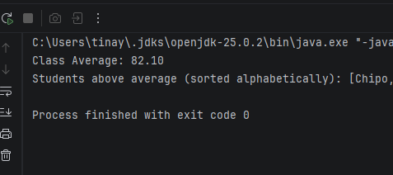

Conclusion
I learned to read and write files with java.nio.file and to process collections declaratively using lamdas and streams
Miniproject
Requirements
Model Book, Member and Loan classes with private fields, validation and tostring
Create an abstract class Libraryitem(tittle,id) and subclasses Book, Dvd each with its loanPeriodDays() (inheritance, polymorphism, abstraction
Define a Borrowable interface with borrow(Member) and giveback()
Create custom exceptions: ItemNotAvailableException and MemberLimitExceededException(maximum 3 loans per member)
Store items and members in Map<String, …> collections keyed by id
Persist data to CSV files on exit and reload on start (lab 10)
Provide a menu with: add item, register member, borrow, return, list overdue items, search by title(using streams)
Book.java
package miniproject;
import java.time.LocalDate;
public class Book extends LibraryItem {
private final String author;
private static final int LOAN_DAYS = 14;
public Book(String id, String title, String author) {
super(id, title);
this.author = author;
}
@Override
public int loanPeriodDays() {
return LOAN_DAYS;
}
@Override
public void borrow(Member member) throws ItemNotAvailableException, MemberLimitExceededException {
if (!isAvailable()) {
throw new ItemNotAvailableException("Book already borrowed: " + getTitle());
}
if (member.getLoans().size() >= 3) {
throw new MemberLimitExceededException(
"Member " + member.getName() + " has reached the maximum of 3 loans."
);
}
setAvailable(false);
Loan loan = new Loan(member, this, LocalDate.now(), LOAN_DAYS);
member.addLoan(loan);
System.out.println("Book borrowed: '" + getTitle() + "' by " + member.getName());
}
@Override
public void giveBack(Member member) {
setAvailable(true);
System.out.println("Book returned: '" + getTitle() + "' by " + member.getName());
}
public String getAuthor() { return author; }
}
Borrowable.java
package miniproject;
public interface Borrowable {
void borrow(Member member) throws ItemNotAvailableException, MemberLimitExceededException;
void giveBack(Member member);
}
Dvd.java
package miniproject;
import java.time.LocalDate;
public class Dvd extends LibraryItem {
private final int runtimeMinutes;
private static final int LOAN_DAYS = 3;
public Dvd(String id, String title, int runtimeMinutes) {
super(id, title);
this.runtimeMinutes = runtimeMinutes;
}
@Override
public int loanPeriodDays() {
return LOAN_DAYS;
}
@Override
public void borrow(Member member) throws ItemNotAvailableException, MemberLimitExceededException {
if (!isAvailable()) {
throw new ItemNotAvailableException("DVD already borrowed: " + getTitle());
}
if (member.getLoans().size() >= 3) {
throw new MemberLimitExceededException(
"Member " + member.getName() + " has reached the maximum of 3 loans."
);
}
setAvailable(false);
Loan loan = new Loan(member, this, LocalDate.now(), LOAN_DAYS);
member.addLoan(loan);
System.out.println("DVD borrowed: '" + getTitle() + "' by " + member.getName());
}
@Override
public void giveBack(Member member) {
setAvailable(true);
System.out.println("DVD returned: '" + getTitle() + "' by " + member.getName());
}
public int getRuntimeMinutes() { return runtimeMinutes; }
}
ItemNotAvailableException.java
package miniproject;
public class ItemNotAvailableException extends Exception {
public ItemNotAvailableException(String message) {
super(message);
}
}
Library.java
package miniproject;
import java.io.IOException;
import java.nio.file.Files;
import java.nio.file.Path;
import java.time.LocalDate;
import java.util.ArrayList;
import java.util.HashMap;
import java.util.List;
import java.util.Map;
import java.util.stream.Collectors;
// EXPLAIN: Core service class. Uses Maps for fast lookups by ID.
public class Library {
private final Map<String, LibraryItem> items = new HashMap<>();
private final Map<String, Member> members = new HashMap<>();
private final List<Loan> loans = new ArrayList<>();
private static final int MAX_LOANS_PER_MEMBER = 3;
public void addItem(LibraryItem item) {
items.put(item.getId(), item);
}
public void registerMember(Member member) {
members.put(member.getId(), member);
}
public void borrow(String memberId, String itemId)
throws ItemNotAvailableException, MemberLimitExceededException {
Member member = members.get(memberId);
if (member == null) throw new IllegalArgumentException("Member not found: " + memberId);
LibraryItem item = items.get(itemId);
if (item == null) throw new IllegalArgumentException("Item not found: " + itemId);
// EXPLAIN: Polymorphism -> calls the borrow() of the actual object type
item.borrow(member);
Loan loan = new Loan(member, item, LocalDate.now(), item.loanPeriodDays());
loans.add(loan);
}
public void giveBack(String memberId, String itemId) {
Member member = members.get(memberId);
LibraryItem item = items.get(itemId);
if (member == null || item == null) return;
item.giveBack(member);
Loan toRemove = null;
for (Loan loan : member.getLoans()) {
if (loan.getItem().getId().equals(itemId)) {
toRemove = loan;
break;
}
}
if (toRemove != null) {
member.removeLoan(toRemove);
loans.remove(toRemove);
}
}
// EXPLAIN: Streams -> filter and sort results
public List<LibraryItem> searchByTitle(String text) {
return items.values().stream()
.filter(i -> i.getTitle().toLowerCase().contains(text.toLowerCase()))
.sorted((a, b) -> a.getTitle().compareToIgnoreCase(b.getTitle()))
.collect(Collectors.toList());
}
// EXPLAIN: Streams -> find overdue items
public List<Loan> listOverdueItems() {
LocalDate today = LocalDate.now();
return loans.stream()
.filter(loan -> loan.isOverdue(today))
.collect(Collectors.toList());
}
// =====================================================
// FILE PERSISTENCE (Requirement 6)
// =====================================================
public void saveToFile(String itemsFile, String membersFile) throws IOException {
// Save items
List<String> itemLines = new ArrayList<>();
for (LibraryItem item : items.values()) {
if (item instanceof Book book) {
itemLines.add("BOOK," + book.getId() + "," + book.getTitle()
+ "," + book.getAuthor() + "," + book.isAvailable());
} else if (item instanceof Dvd dvd) {
itemLines.add("DVD," + dvd.getId() + "," + dvd.getTitle()
+ "," + dvd.getRuntimeMinutes() + "," + dvd.isAvailable());
}
}
Files.write(Path.of(itemsFile), itemLines);
// Save members
List<String> memberLines = new ArrayList<>();
for (Member m : members.values()) {
memberLines.add(m.getId() + "," + m.getName());
}
Files.write(Path.of(membersFile), memberLines);
System.out.println("Library data saved to " + itemsFile + " and " + membersFile);
}
public void loadFromFile(String itemsFile, String membersFile) throws IOException {
// Load items
Path itemsPath = Path.of(itemsFile);
if (Files.exists(itemsPath)) {
for (String line : Files.readAllLines(itemsPath)) {
String[] p = line.split(",");
if (p.length < 5) continue;
String type = p[0];
String id = p[1];
String title = p[2];
boolean available = Boolean.parseBoolean(p[4]);
LibraryItem item;
if (type.equals("BOOK")) {
item = new Book(id, title, p[3]);
} else {
item = new Dvd(id, title, Integer.parseInt(p[3]));
}
item.setAvailable(available);
items.put(id, item);
}
System.out.println("Loaded " + items.size() + " items from " + itemsFile);
}
// Load members
Path membersPath = Path.of(membersFile);
if (Files.exists(membersPath)) {
for (String line : Files.readAllLines(membersPath)) {
String[] p = line.split(",");
if (p.length < 2) continue;
members.put(p[0], new Member(p[0], p[1]));
}
System.out.println("Loaded " + members.size() + " members from " + membersFile);
}
}
LibraryApp.java
package miniproject;
import java.util.List;
import java.util.Scanner;
public class LibraryApp {
private static final Library library = new Library();
private static final Scanner scanner = new Scanner(System.in);
private static final String ITEMS_FILE = "items.csv";
private static final String MEMBERS_FILE = "members.csv";
public static void main(String[] args) {
// Load saved data on startup
try {
library.loadFromFile(ITEMS_FILE, MEMBERS_FILE);
} catch (Exception e) {
System.out.println("No saved data found. Starting fresh.");
}
seedData();
// Save on exit
Runtime.getRuntime().addShutdownHook(new Thread(() -> {
try {
library.saveToFile(ITEMS_FILE, MEMBERS_FILE);
} catch (Exception e) {
System.out.println("Could not save data: " + e.getMessage());
}
}));
while (true) {
System.out.println("\n--- Library Management System ---");
System.out.println("1. Add Item");
System.out.println("2. Register Member");
System.out.println("3. Borrow Item");
System.out.println("4. Return Item");
System.out.println("5. Search by Title");
System.out.println("6. List Overdue Items");
System.out.println("7. Save Data");
System.out.println("0. Exit");
System.out.print("Choose: ");
String choice = scanner.nextLine();
try {
switch (choice) {
case "1" -> addItem();
case "2" -> registerMember();
case "3" -> borrowItem();
case "4" -> returnItem();
case "5" -> searchByTitle();
case "6" -> listOverdue();
case "7" -> library.saveToFile(ITEMS_FILE, MEMBERS_FILE);
case "0" -> { System.out.println("Goodbye!"); System.exit(0); }
default -> System.out.println("Invalid option.");
}
} catch (Exception e) {
System.out.println("Error: " + e.getMessage());
}
}
}
private static void addItem() {
System.out.print("Type (BOOK/DVD): ");
String type = scanner.nextLine().toUpperCase();
System.out.print("ID: ");
String id = scanner.nextLine();
System.out.print("Title: ");
String title = scanner.nextLine();
if (type.equals("BOOK")) {
System.out.print("Author: ");
String author = scanner.nextLine();
library.addItem(new Book(id, title, author));
} else if (type.equals("DVD")) {
System.out.print("Runtime (mins): ");
int runtime = Integer.parseInt(scanner.nextLine());
library.addItem(new Dvd(id, title, runtime));
} else {
System.out.println("Invalid type.");
return;
}
System.out.println("Item added.");
}
private static void registerMember() {
System.out.print("Member ID: ");
String id = scanner.nextLine();
System.out.print("Name: ");
String name = scanner.nextLine();
library.registerMember(new Member(id, name));
System.out.println("Member registered.");
}
private static void borrowItem() {
System.out.print("Member ID: ");
String mId = scanner.nextLine();
System.out.print("Item ID: ");
String iId = scanner.nextLine();
try {
library.borrow(mId, iId);
} catch (ItemNotAvailableException e) {
System.out.println("Cannot borrow: " + e.getMessage());
} catch (MemberLimitExceededException e) {
System.out.println("Cannot borrow: " + e.getMessage());
}
}
private static void returnItem() {
System.out.print("Member ID: ");
String mId = scanner.nextLine();
System.out.print("Item ID: ");
String iId = scanner.nextLine();
library.giveBack(mId, iId);
}
private static void searchByTitle() {
System.out.print("Search text: ");
String text = scanner.nextLine();
List<LibraryItem> results = library.searchByTitle(text);
if (results.isEmpty()) {
System.out.println("No items found.");
} else {
results.forEach(System.out::println);
}
}
private static void listOverdue() {
List<Loan> overdue = library.listOverdueItems();
if (overdue.isEmpty()) {
System.out.println("No overdue items.");
} else {
overdue.forEach(System.out::println);
}
}
private static void seedData() {
library.addItem(new Book("B1", "The Great Gatsby", "F. Scott Fitzgerald"));
library.addItem(new Book("B2", "1984", "George Orwell"));
library.addItem(new Dvd("D1", "Inception", 148));
library.registerMember(new Member("M1", "Tinashe"));
library.registerMember(new Member("M2", "Rudo"));
}
}

Output
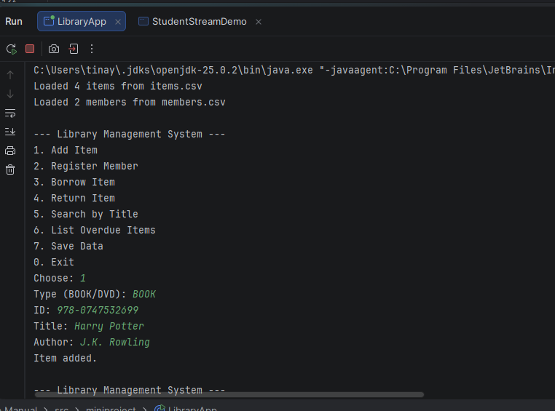
Loan.java
package miniproject;
import java.time.LocalDate;
public class Loan {
private final Member member;
private final LibraryItem item;
private final LocalDate borrowDate;
private final LocalDate dueDate;
public Loan(Member member, LibraryItem item, LocalDate borrowDate, int loanDays) {
this.member = member;
this.item = item;
this.borrowDate = borrowDate;
this.dueDate = borrowDate.plusDays(loanDays);
}
public Member getMember() { return member; }
public LibraryItem getItem() { return item; }
public LocalDate getDueDate() { return dueDate; }
public boolean isOverdue(LocalDate today) {
return today.isAfter(dueDate);
}
@Override
public String toString() {
return "Loan[item=" + item.getTitle() + ", member=" + member.getName() + ", due=" + dueDate + "]";
}
}
Member.java
package miniproject;
import java.util.ArrayList;
import java.util.List;
public class Member {
private final String id;
private final String name;
private final List<Loan> loans = new ArrayList<>();
public Member(String id, String name) {
if (id == null || id.isBlank()) throw new IllegalArgumentException("Member ID required");
if (name == null || name.isBlank()) throw new IllegalArgumentException("Member name required");
this.id = id;
this.name = name;
}
public String getId() { return id; }
public String getName() { return name; }
public List<Loan> getLoans() { return loans; }
public void addLoan(Loan loan) { loans.add(loan); }
public void removeLoan(Loan loan) { loans.remove(loan); }
@Override
public String toString() {
return "Member[id=" + id + ", name=" + name + ", activeLoans=" + loans.size() + "]";
}
MemberLimitExceededException.java
package miniproject;
public class MemberLimitExceededException extends Exception {
public MemberLimitExceededException(String message) {
super(message);
}
}
Conclusion
The mini project combined abstraction, polymorphism, custom exceptions, collections, streams and file persistence into one working Library management system.

Class Diagram for Library management system
